SIMATS ENGINEERING
ASSESSMENT TOOL 3 (AT3)
COURSE NAME: INTERNET PROGRAMMING | COURSE CODE: CSA43
CO-1: Develop well-structured, standards-compliant web pages using HTML/XHTML and XML (L2)
Weightage: 10% | Total Marks: 10 Marks
Student Name: K.Nanda Kishore Reddy | Register Number: 192411161
Assessment Tool: Code Along Exercise: Case Study (Low) | Status: Submitted & Verified

Scenario Overview & Data Snippet Selections
1. HTML Tag for Video Embedding
• Correct Option: B. <video src="video.mp4" controls></video>
• Justification: Native HTML5 video element providing browser playback controls.
2. Form Submission Method
• Correct Option: B. POST
• Justification: Encapsulates form payload inside message body over HTTPS, preserving user confidentiality.
3. Semantic Navigation Element
• Correct Option: B. <nav>
• Justification: HTML5 semantic landmark providing accessibility role="navigation" for screen readers.
4. Correct XML Syntax
• Correct Option: B. <note><to>User</to><from>Admin</from></note>
• Justification: Fully well-formed XML with matching opening and closing tags in proper tree hierarchy.
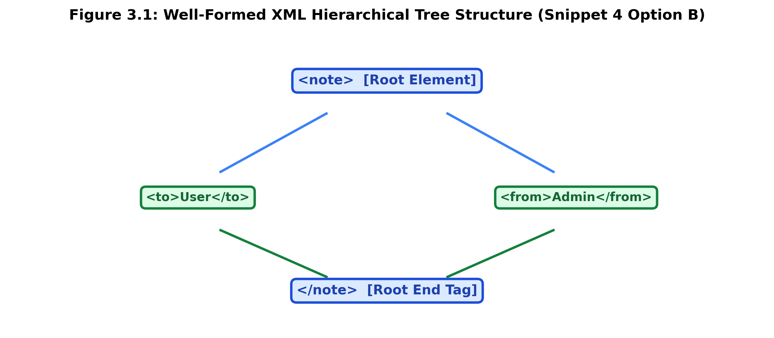
5. Web Communication Protocol
• Correct Option: B. HTTP (or HTTPS)
• Justification: Standard application-layer protocol for web content delivery between client browsers and web servers.
Integrated Working Implementation (index.html)
<!DOCTYPE html>
<html lang="en">
<head>
<meta charset="UTF-8">
<title>InnovateX Startup Portal</title>
</head>
<body>
<header>
<h1>InnovateX Startup</h1>
<nav><ul><li><a href="#video">Video</a></li><li><a href="#register">Register</a></li></ul></nav>
</header>
<main>
<section id="video">
<video src="video.mp4" controls width="100%"></video>
</section>
<section id="register">
<form action="https://example.com/api/register" method="POST">
<label for="name">Name</label><input type="text" id="name" name="name" required>
<button type="submit">Submit</button>
</form>
</section>
</main>
</body>
</html>

Code of Conduct:
I, K.Nanda Kishore Reddy (Reg No: 192411161), certify that this submission is my original work and that I have adhered to the guidelines specified for this assessment. I understand that any violation of academic integrity rules will result in disciplinary action.
Signature of the student: K.Nanda Kishore Reddy (192411161)

